COGS 17 A05 Week 1 Problem Set

1) Match the planar Views with the following terms: coronal plane, horizontal plane, and sagittal plane.

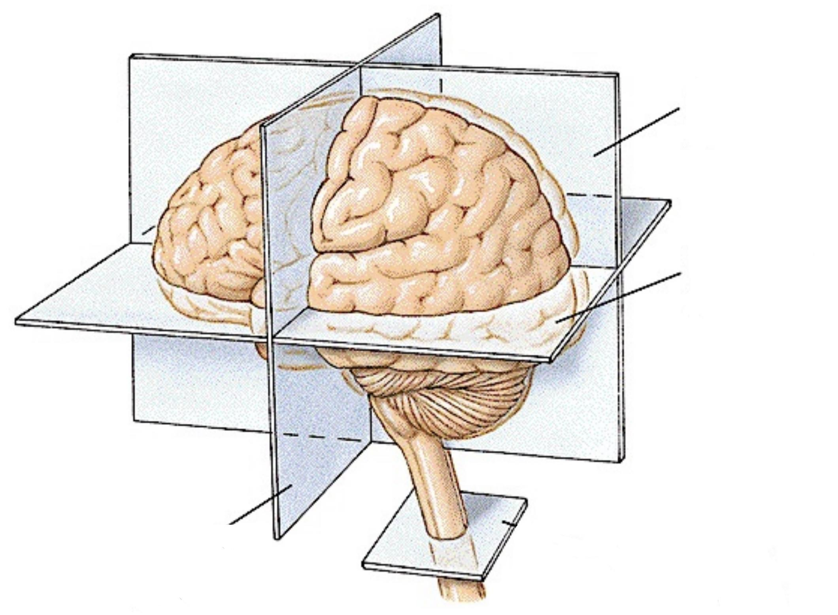

Sagittal Plane

Horizontal Plane

Coronal Plane

2) A tumor involving the left side of the brain may cause paralysis of the right leg. Is this an example of an ipsilateral connection or a contralateral connection?

A tumor involving the left side of the brain causing paralysis of the right leg is an example of a **contralateral connection**, where the left brain controls the right side of the body

3) The central nervous system is sheathed in the 3-layered meninges, what are the three layers? Indicate in the graph.

Arachnoid mater

Pia mater

Dura mater

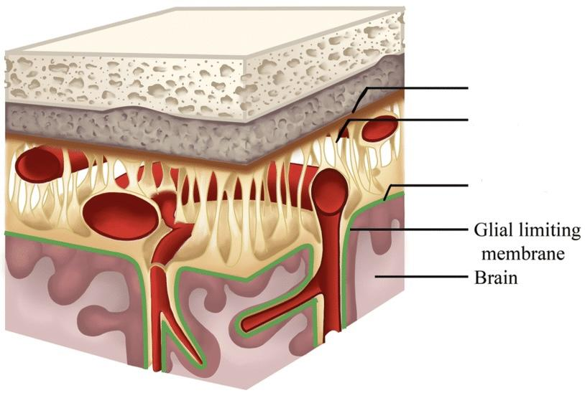

4) How many ventricles are there in the brain? Where are they located? What is the main function of ventricles?

There are **four ventricles** in the brain:

• Two **lateral ventricles** in the forebrain.

• The **third ventricle**, located centrally in the forebrain.

• The **fourth ventricle**, in the hindbrain.

• Their main function is to produce **cerebrospinal fluid (CSF)**, which cushions the brain and provides nutrients

5) What are the main functions of the blood-brain barrier? What particles can passively cross the barrier?

The **blood-brain barrier** protects the brain by regulating which substances can enter the brain tissue. **Small uncharged molecules** (e.g., O2, CO2) and **fat-soluble molecules** (e.g., nicotine, heroin) can cross passively.

6) What are the major functions of Medulla, Pons, and cerebellum?

• **Medulla**: Controls vital reflexes such as breathing, heart rate, and vomiting.

• **Pons**: Relays information between the cortex and cerebellum and between the brain and spinal cord.

• **Cerebellum**: Organizes sensory input to guide movement and is involved in motor coordination and balance.

7) What makes up the midbrain and what are the functions of each of those parts?

The **midbrain** consists of:

• **Tectum**: Includes the superior colliculus (vision) and inferior colliculus (audition).

• **Tegmentum**: Contains structures involved in motor control, including the red nucleus and substantia nigra.

8) What are the two divisions of the forebrain?

The two divisions of the forebrain are the **diencephalon** and the **telencephalon**.

9) What makes up the diencephalon and what are the functions of those parts?

The **diencephalon** is made up of:

• **Thalamus**: Relays sensory and motor signals to the cerebral cortex.

• **Hypothalamus**: Regulates homeostatic functions like feeding, fighting, fleeing, and reproduction.

10) What makes up the telencephalon and what are the functions of those parts?

The **telencephalon** consists of:

• **Limbic system**: Involved in emotional and motivational behavior.

• **Basal ganglia**: Important for movement control.

• **Cerebral cortex**: Responsible for higher-level functions such as sensory perception, cognition, and motor commands.

11) Name the four lobes of the brain. What are the main functions of each lobe?

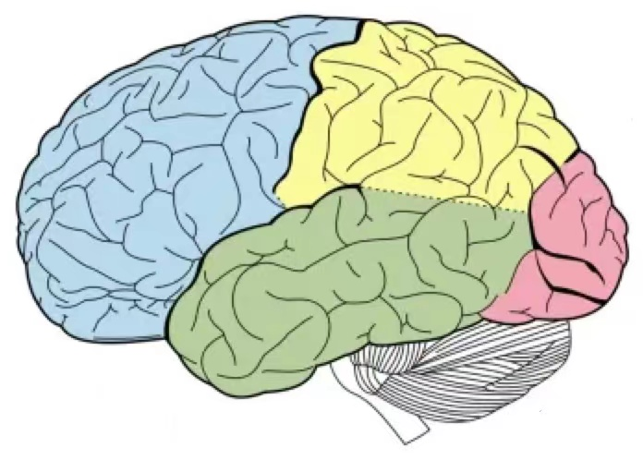

Temporal Lobe

Parietal Lobe Lobe

Occipital Lobe Lobe

Frontal Lobe

The four **lobes of the brain** and their functions:

• **Occipital lobe**: Visual processing.

• **Temporal lobe**: Auditory processing, language comprehension, and emotional processing.

• **Parietal lobe**: Somatosensory processing and spatial mapping.

• **Frontal lobe**: Motor control, language production, and executive functions.